UNIT-1

PROGRAM 1
AIM: Install Matplotlib and display a simple line graph.
CODE:
import matplotlib.pyplot as plt
x = [1, 2, 3, 4, 5]
y = [2, 4, 6, 8, 10]
plt.plot(x, y, marker="o", label="y = 2x")
plt.title("Simple Line Graph")
plt.xlabel("X values")
plt.ylabel("Y values")
plt.grid(True)
plt.legend()
plt.tight_layout()
plt.show()
OUTPUT:
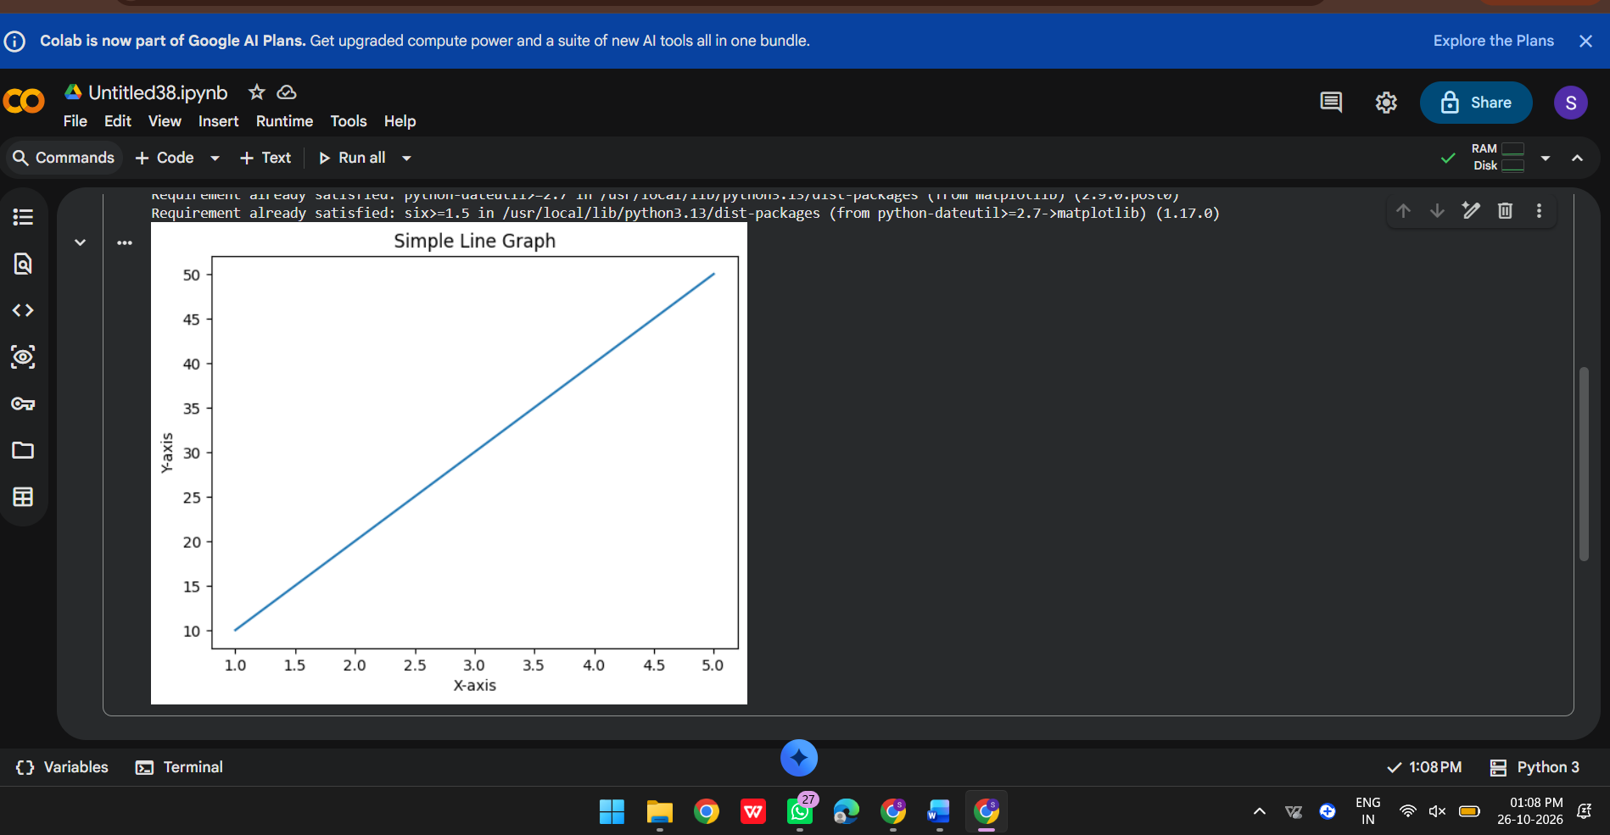
RESULT: Displays a line graph with points (1,2), (2,4), (3,6), (4,8), and (5,10). Install first with: python -m pip install matplotlib.
PROGRAM 2
AIM: Install Scikit-learn and print its version.
CODE:
import sklearn
print("Scikit-learn version:", sklearn.__version__)
OUTPUT:
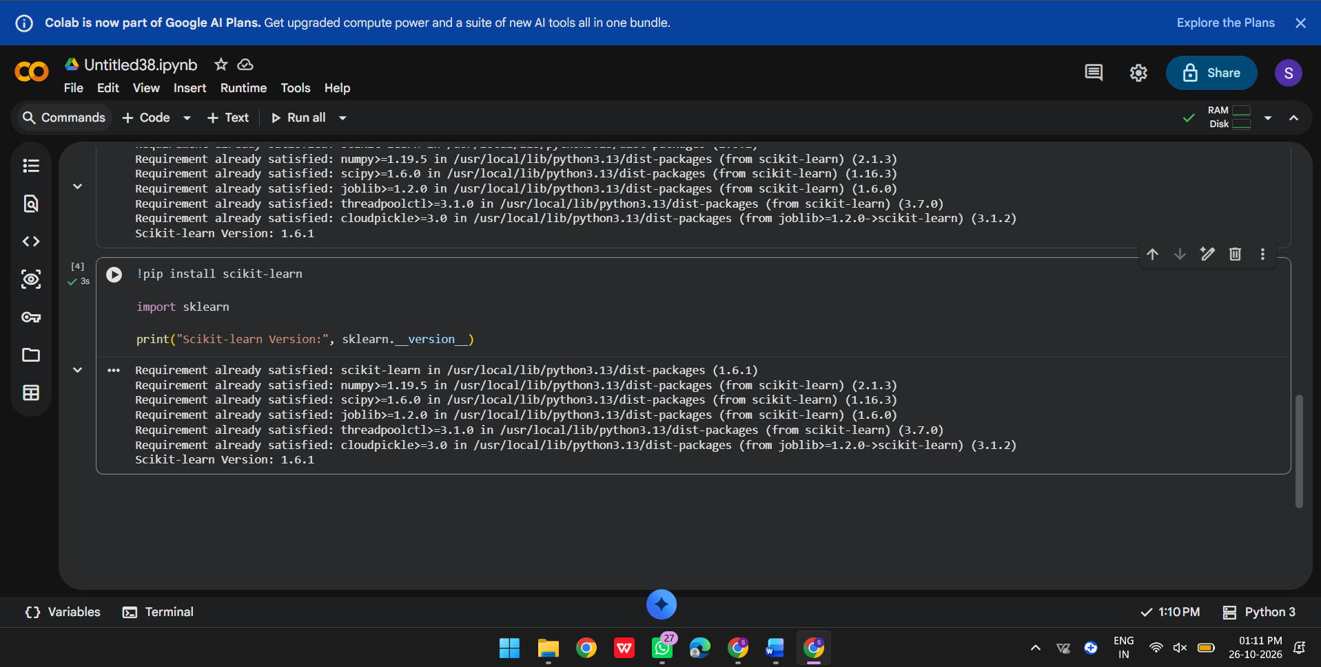
RESULT: Prints the installed Scikit-learn version, for example: Scikit-learn version: 1.x.x. The exact version depends on the environment. Install with: python -m pip install scikit-learn.

PROGRAM 3
AIM: Create a NumPy array containing the first 20 natural numbers.
CODE:
import numpy as np
numbers = np.arange(1, 21)
print("First 20 natural numbers:")
print(numbers)
OUTPUT:
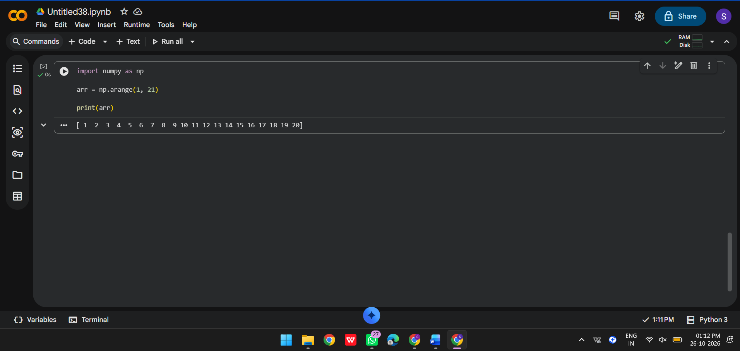
RESULT: Prints an array containing the integers from 1 through 20. Install with: python -m pip install numpy.

PROGRAM 4
AIM: Create a Pandas DataFrame with student names and grades.
CODE:
import pandas as pd
data = {
"Student": ["Asha", "Rahul", "Meena", "Arun"],
"Grade": ["A", "B", "A+", "B+"]
}
df = pd.DataFrame(data)
print(df)
OUTPUT:
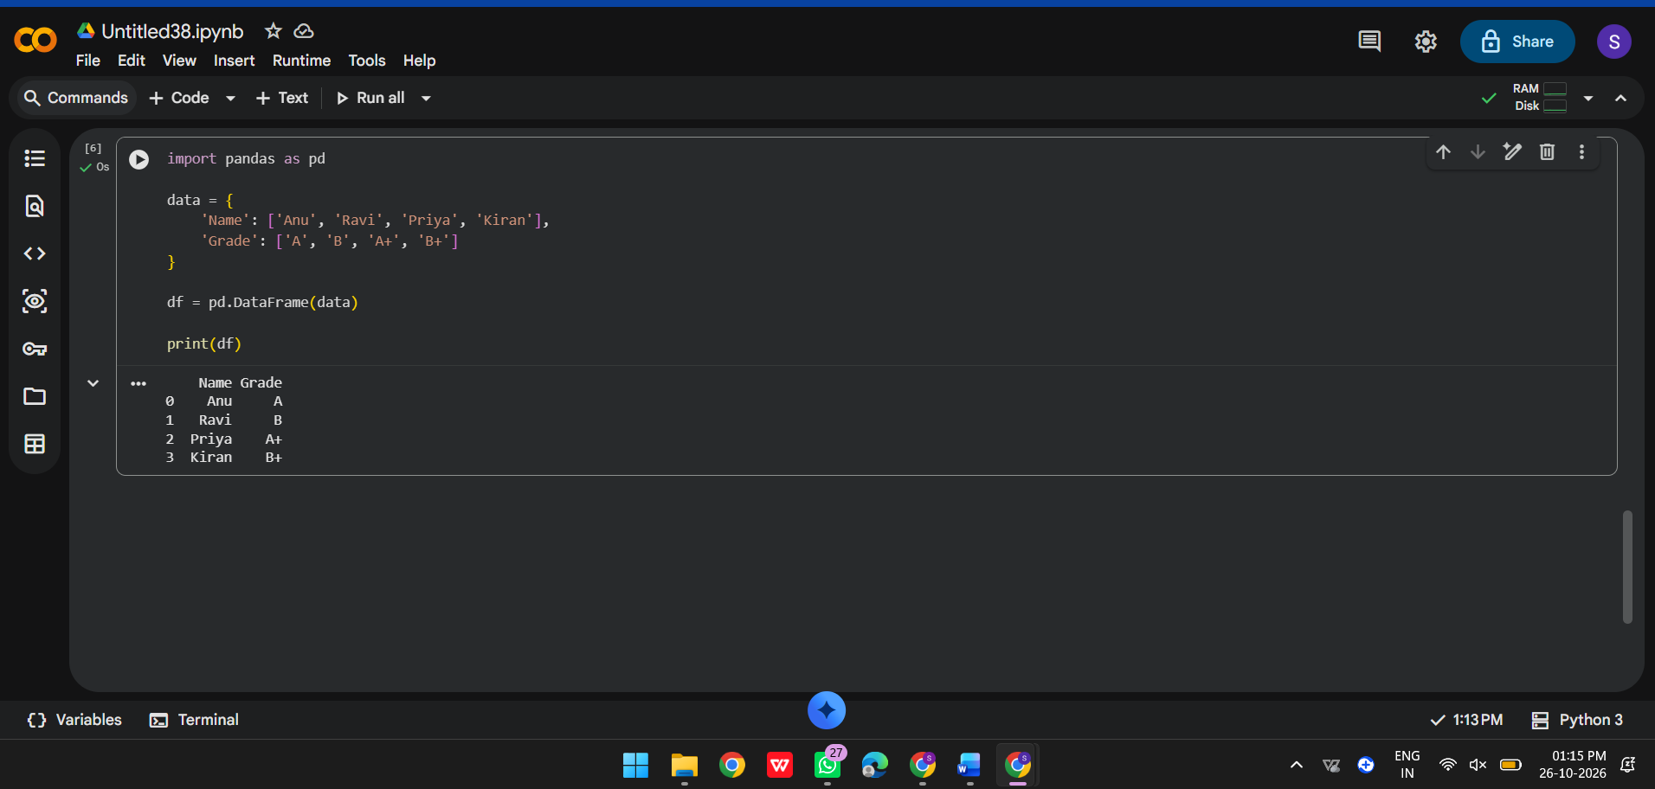
RESULT: Displays a two-column DataFrame with four students and their grades. Install with: python -m pip install pandas.

PROGRAM 5
AIM: Verify the installed versions of all AI libraries on your system.
CODE:
from importlib.metadata import version, PackageNotFoundError
packages = [
"numpy", "pandas", "matplotlib", "scikit-learn",
"torch", "transformers", "tokenizers", "datasets",
"tensorflow", "keras", "sentencepiece", "accelerate"
]
for package in packages:
try:
print(f"{package}: {version(package)}")
except PackageNotFoundError:
print(f"{package}: not installed")
OUTPUT:

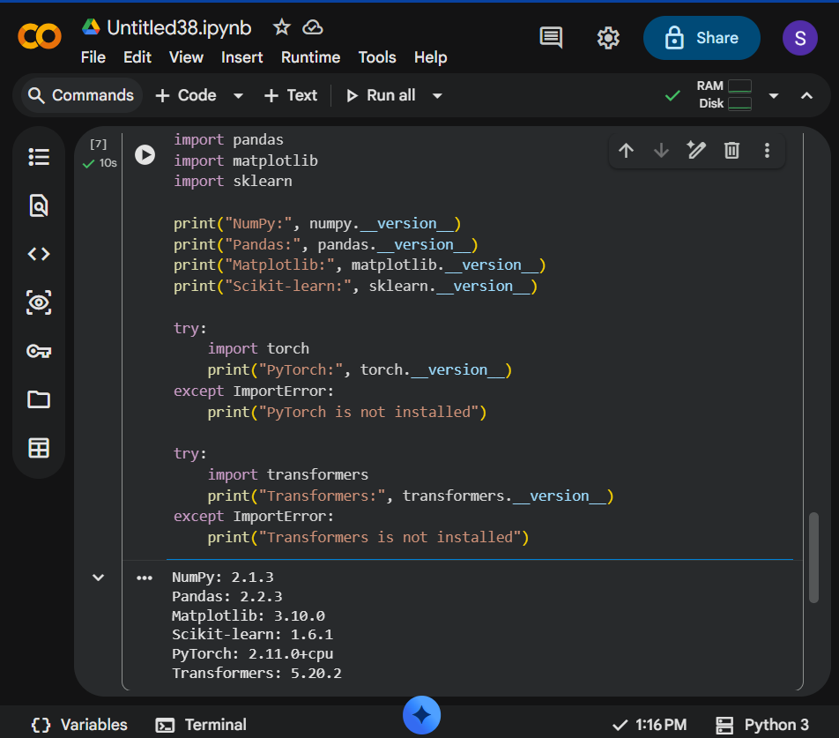
RESULT: Lists the installed version of each package, or reports 'not installed'. The output depends on the packages available in your Python environment.

PROGRAM 6
AIM: Create tensors using PyTorch and perform basic mathematical operations.
CODE:
import torch
a = torch.tensor([1.0, 2.0, 3.0])
b = torch.tensor([4.0, 5.0, 6.0])
print("Tensor A:", a)
print("Tensor B:", b)
print("Addition:", a + b)
print("Subtraction:", a - b)
print("Multiplication:", a * b)
print("Division:", a / b)
OUTPUT:

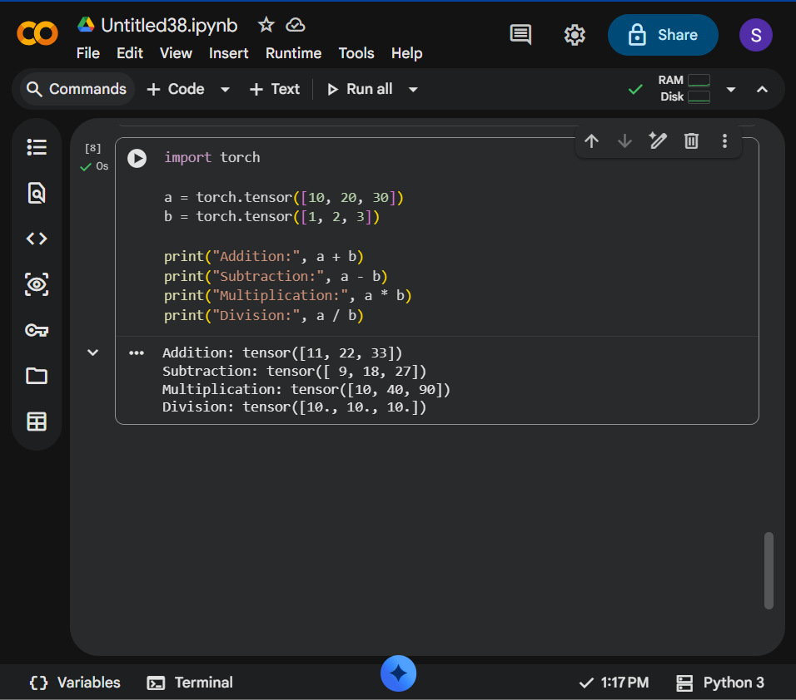
RESULT: Shows two tensors and element-wise addition [5, 7, 9], subtraction [-3, -3, -3], multiplication [4, 10, 18], and division [0.25, 0.4, 0.5]. Install with: python -m pip install torch.

PROGRAM 7
AIM: Load a pre-trained Transformer model using Hugging Face and perform sentiment analysis.
CODE:
from transformers import pipeline
sentiment = pipeline("sentiment-analysis")
texts = [
"This product is excellent and very useful.",
"I am disappointed with the poor service."
]
for text in texts:
print(text)
print(sentiment(text))
OUTPUT:

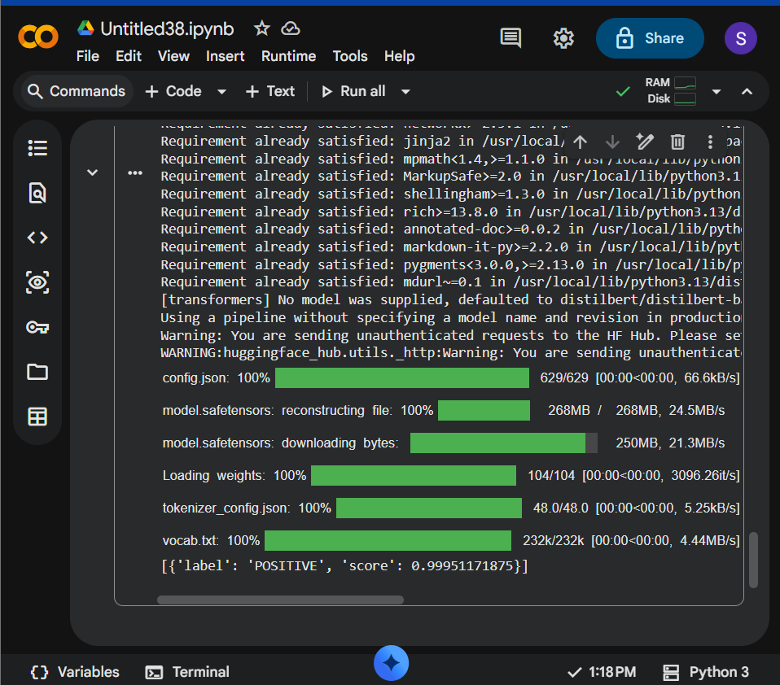
RESULT: Returns a sentiment label (typically POSITIVE or NEGATIVE) and a confidence score for each sentence. The pipeline downloads a default model on first use and requires internet access unless cached.

PROGRAM 8
AIM: Perform tokenization using a BERT tokenizer.
CODE:
from transformers import BertTokenizer
tokenizer = BertTokenizer.from_pretrained("bert-base-uncased")
sentence = "Transformers make language processing powerful."
tokens = tokenizer.tokenize(sentence)
print("Sentence:", sentence)
print("Tokens:", tokens)
OUTPUT:

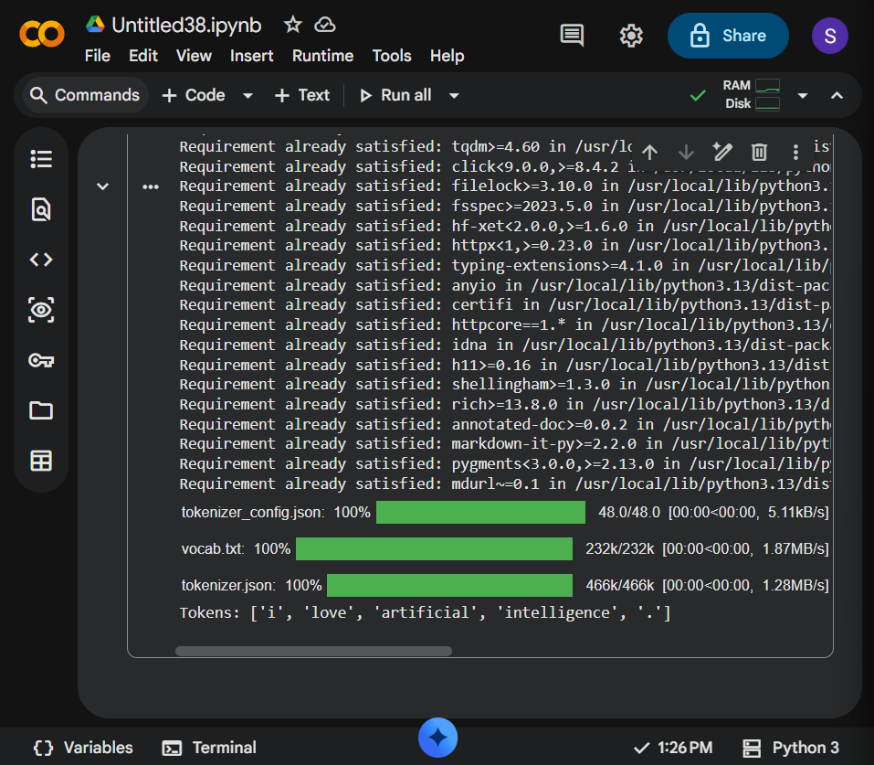
RESULT: Prints the sentence and BERT's WordPiece tokens. The tokenizer files are downloaded on first use and then cached.

PROGRAM 9
AIM: Generate text using a pre-trained GPT-2 model.
CODE:
from transformers import pipeline
generator = pipeline("text-generation", model="gpt2")
prompt = "Artificial intelligence can help people by"
result = generator(
prompt,
max_new_tokens=40,
do_sample=True,
temperature=0.8,
pad_token_id=generator.tokenizer.eos_token_id
)
print(result[0]["generated_text"])
OUTPUT:

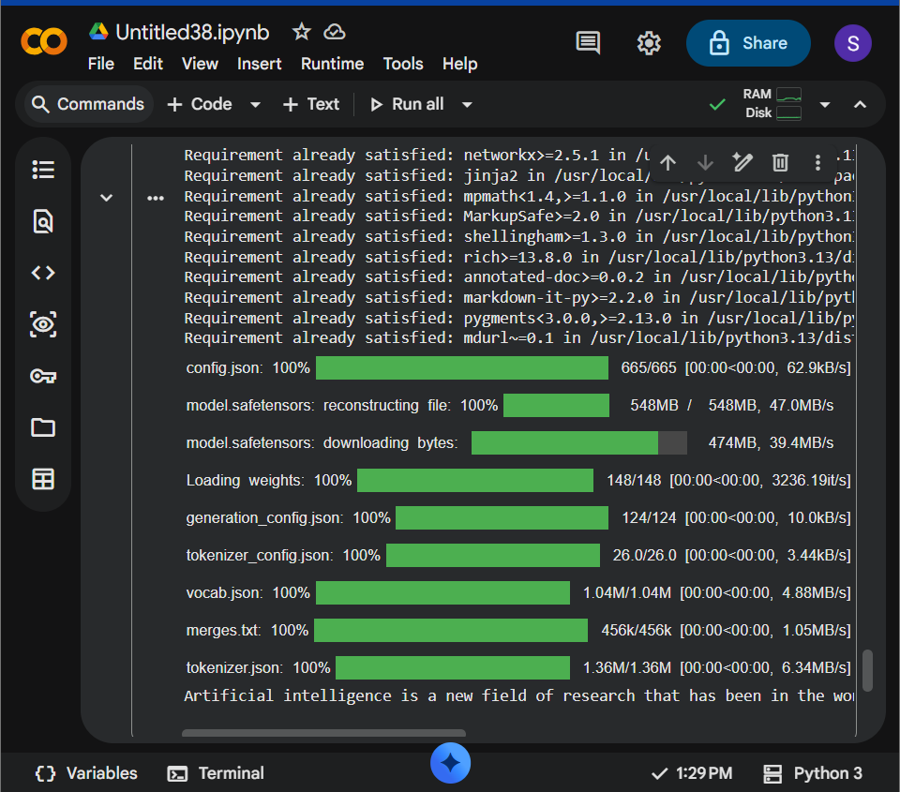
RESULT: Prints the prompt followed by up to 40 newly generated tokens. Generated wording can vary between runs. The GPT-2 model must be downloaded on first use.

PROGRAM 10
AIM: Load a pre-trained Transformer model using Hugging Face pipeline() and perform sentiment analysis.
CODE:
from transformers import pipeline
classifier = pipeline(
task="sentiment-analysis",
model="distilbert/distilbert-base-uncased-finetuned-sst-2-english"
)
result = classifier("The lecture was clear, interesting, and helpful.")
print(result)
OUTPUT:

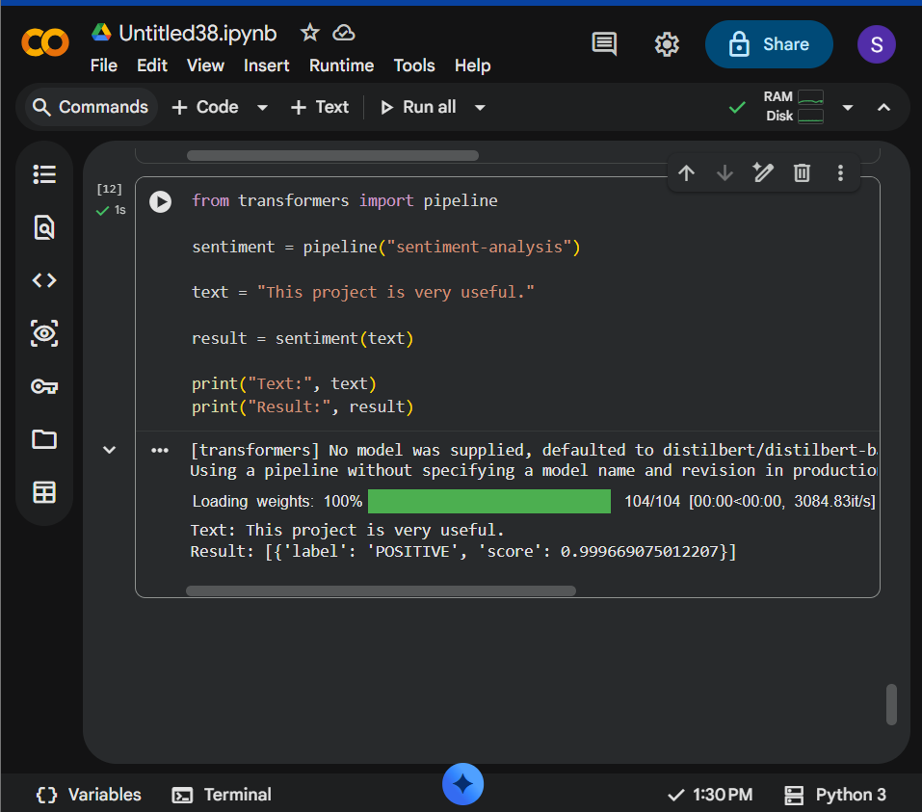
RESULT: Prints a sentiment label and confidence score. This example explicitly selects a DistilBERT sentiment model; first use may require an internet connection.

PROGRAM 11
AIM: Load the BERT tokenizer and tokenize a sentence.
CODE:
from transformers import BertTokenizer
tokenizer = BertTokenizer.from_pretrained("bert-base-uncased")
sentence = "Machine learning learns patterns from data."
encoded = tokenizer(sentence)
print("Input IDs:", encoded["input_ids"])
print("Tokens:", tokenizer.convert_ids_to_tokens(encoded["input_ids"]))
OUTPUT:

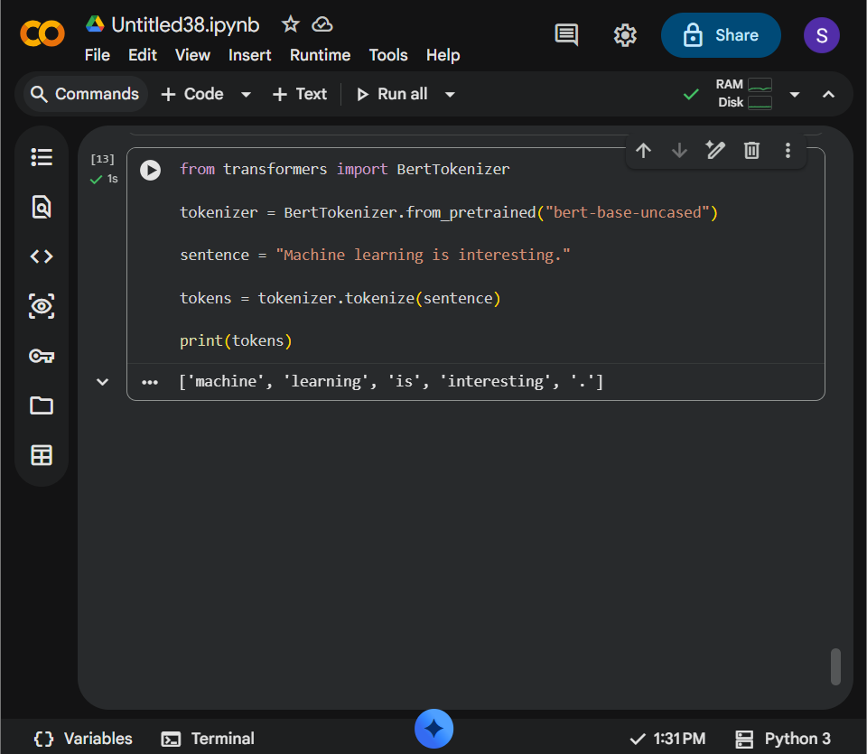
RESULT: Displays the token IDs and corresponding tokens, including special tokens such as [CLS] and [SEP].

PROGRAM 12
AIM: Load a pre-trained BERT model and generate contextual embeddings.
CODE:
import torch
from transformers import BertTokenizer, BertModel
tokenizer = BertTokenizer.from_pretrained("bert-base-uncased")
model = BertModel.from_pretrained("bert-base-uncased")
sentence = "BERT creates contextual representations of words."
inputs = tokenizer(sentence, return_tensors="pt")
with torch.no_grad():
outputs = model(**inputs)
print("Last hidden state shape:", outputs.last_hidden_state.shape)
print("Sentence embedding shape:", outputs.last_hidden_state[:, 0, :].shape)
OUTPUT:

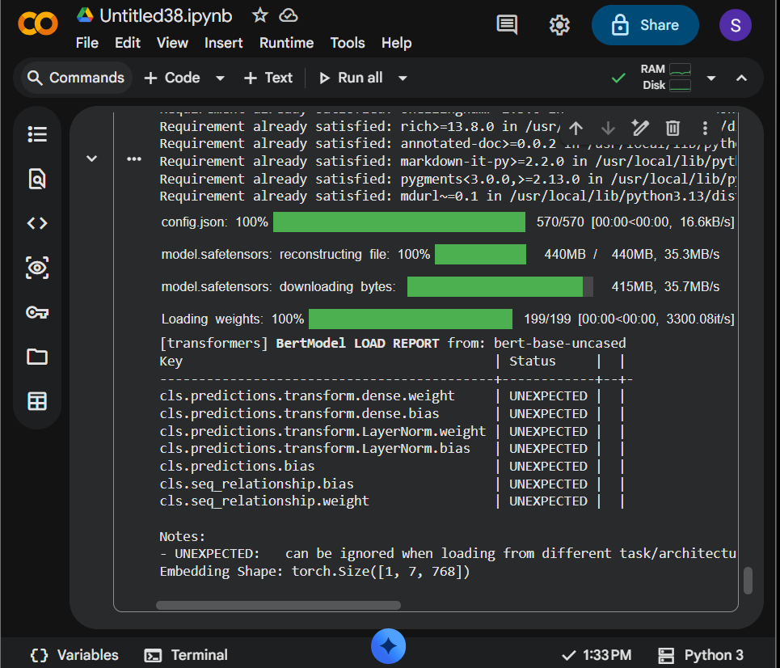
RESULT: Prints the token-level embedding shape (batch size, token count, 768) and the [CLS] vector shape (1, 768). These are contextual representations from the pre-trained model.

PROGRAM 13
AIM: Generate text using a pre-trained GPT-2 model.
CODE:
from transformers import GPT2LMHeadModel, GPT2Tokenizer
model_name = "gpt2"
tokenizer = GPT2Tokenizer.from_pretrained(model_name)
model = GPT2LMHeadModel.from_pretrained(model_name)
prompt = "The future of renewable energy"
inputs = tokenizer(prompt, return_tensors="pt")
outputs = model.generate(
**inputs,
max_new_tokens=35,
do_sample=True,
top_k=50,
pad_token_id=tokenizer.eos_token_id
)
print(tokenizer.decode(outputs[0], skip_special_tokens=True))
OUTPUT:

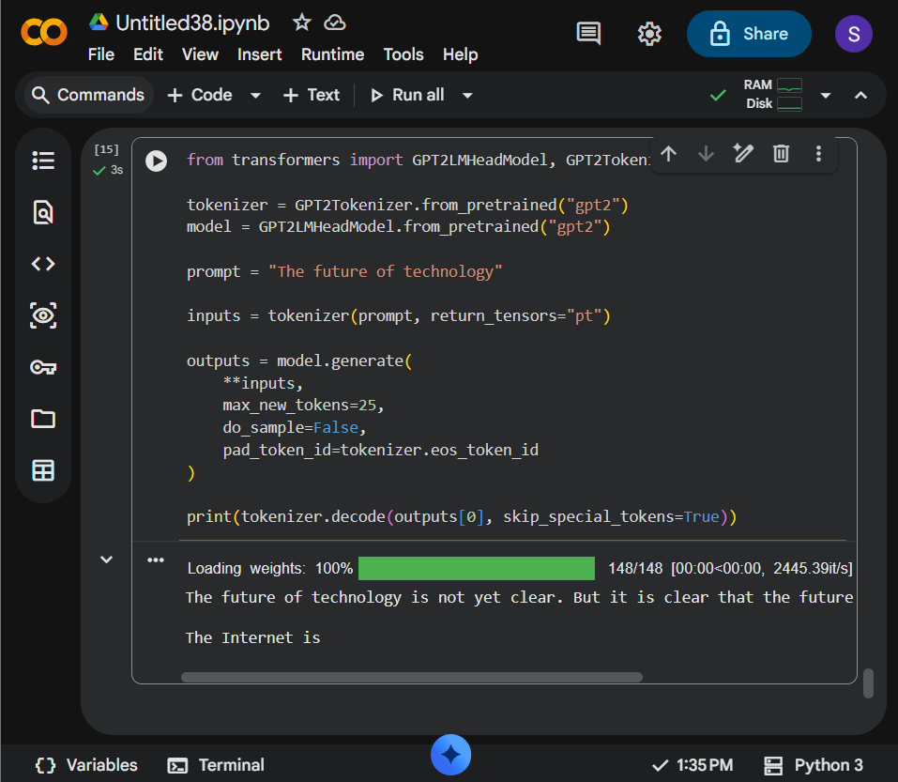
RESULT: Prints the original prompt followed by generated text. Exact text varies because sampling is enabled.

PROGRAM 14
AIM: Perform question answering using a pre-trained Transformer.
CODE:
from transformers import pipeline
qa = pipeline(
"question-answering",
model="distilbert/distilbert-base-cased-distilled-squad"
)
context = (
"The Python programming language was created by Guido van Rossum "
"and first released in 1991."
)
question = "Who created Python?"
answer = qa(question=question, context=context)
print("Question:", question)
print("Answer:", answer["answer"])
print("Confidence:", round(answer["score"], 3))
OUTPUT:

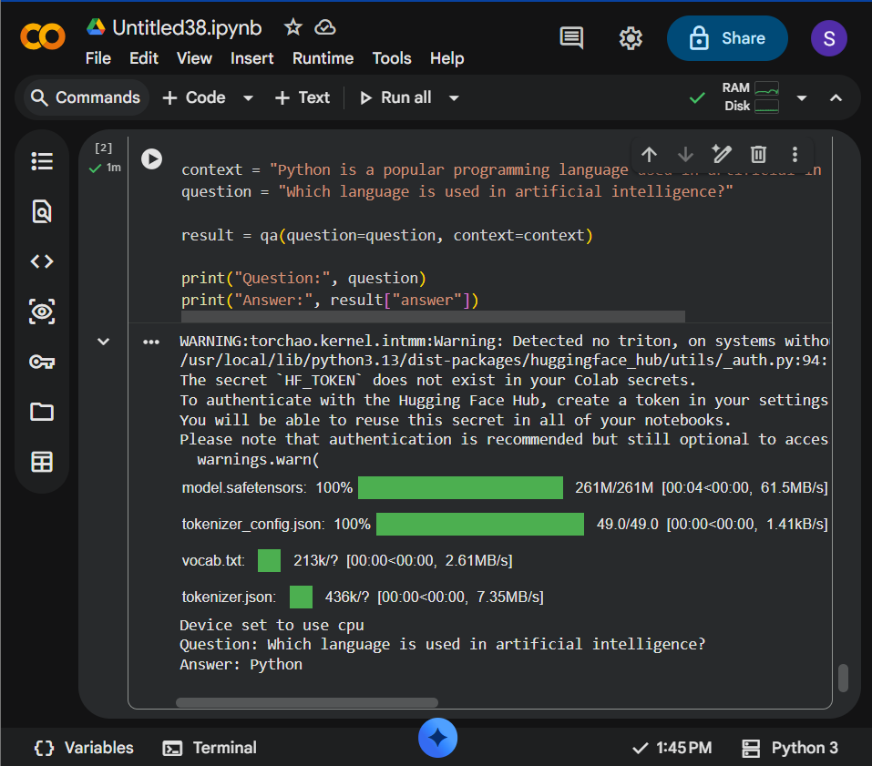
RESULT: Returns 'Guido van Rossum' as the answer, with a model confidence score. The answer is extracted from the supplied context.

PROGRAM 15
AIM: Tokenize a sentence using BERT and display tokens and token IDs.
CODE:
from transformers import BertTokenizer
tokenizer = BertTokenizer.from_pretrained("bert-base-uncased")
sentence = "Natural language processing is fascinating."
encoded = tokenizer(sentence, add_special_tokens=True)
tokens = tokenizer.convert_ids_to_tokens(encoded["input_ids"])
print("Sentence:", sentence)
print("Tokens:", tokens)
print("Token IDs:", encoded["input_ids"])
OUTPUT:

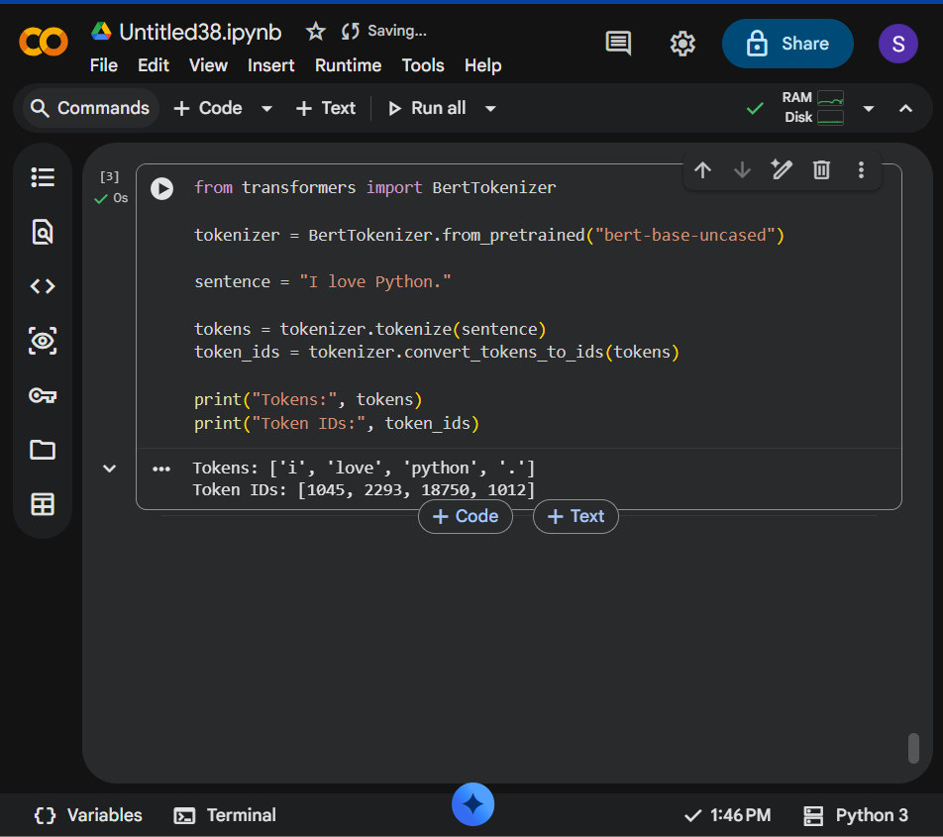
RESULT: Displays BERT tokens and their numeric IDs, including [CLS] and [SEP].

PROGRAM 16
AIM: Compare the tokenization outputs of BERT and GPT-2.
CODE:
from transformers import BertTokenizer, GPT2Tokenizer
sentence = "Tokenization helps language models process text."
bert = BertTokenizer.from_pretrained("bert-base-uncased")
gpt2 = GPT2Tokenizer.from_pretrained("gpt2")
print("Sentence:", sentence)
print("\nBERT tokens:")
print(bert.tokenize(sentence))
print("\nGPT-2 tokens:")
print(gpt2.tokenize(sentence))
OUTPUT:

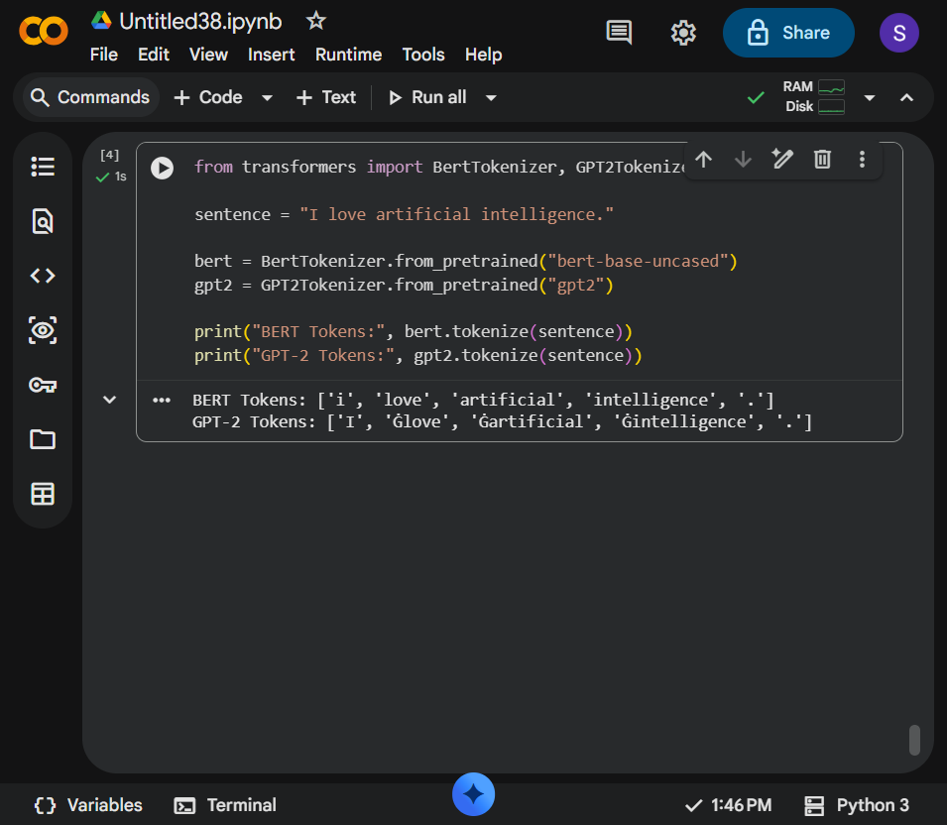
RESULT: Prints two token lists. BERT uses WordPiece tokenization and lowercases text with this checkpoint; GPT-2 uses byte-level BPE, so token boundaries can differ.

PROGRAM 17
AIM: Generate contextual embeddings for a sentence using BERT.
CODE:
import torch
from transformers import AutoTokenizer, AutoModel
model_name = "bert-base-uncased"
tokenizer = AutoTokenizer.from_pretrained(model_name)
model = AutoModel.from_pretrained(model_name)
sentence = "Contextual embeddings represent words in context."
inputs = tokenizer(sentence, return_tensors="pt")
with torch.no_grad():
outputs = model(**inputs)
token_embeddings = outputs.last_hidden_state
print("Token embedding tensor shape:", tuple(token_embeddings.shape))
print("First token embedding (first 5 values):")
print(token_embeddings[0, 0, :5].tolist())
OUTPUT:

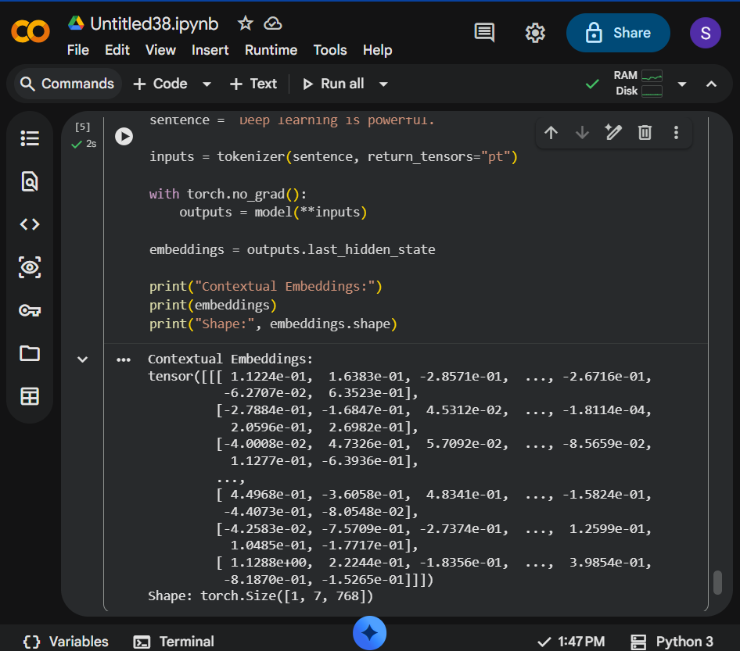
RESULT: Prints a tensor shape of (1, number_of_tokens, 768) and the first five values of the first token's embedding. Floating-point values are model outputs.

PROGRAM 18
AIM: Compare contextual embeddings generated for two semantically similar sentences.
CODE:
import torch
import torch.nn.functional as F
from transformers import AutoTokenizer, AutoModel
name = "sentence-transformers/all-MiniLM-L6-v2"
tokenizer = AutoTokenizer.from_pretrained(name)
model = AutoModel.from_pretrained(name)
sentences = [
"A child is playing outside.",
"A kid is playing outdoors."
]
inputs = tokenizer(sentences, padding=True, truncation=True, return_tensors="pt")
with torch.no_grad():
output = model(**inputs).last_hidden_state
mask = inputs["attention_mask"].unsqueeze(-1)
embeddings = (output * mask).sum(dim=1) / mask.sum(dim=1)
similarity = F.cosine_similarity(embeddings[0], embeddings[1], dim=0)
print("Embedding shape:", tuple(embeddings.shape))
print("Cosine similarity:", round(similarity.item(), 4))
OUTPUT:

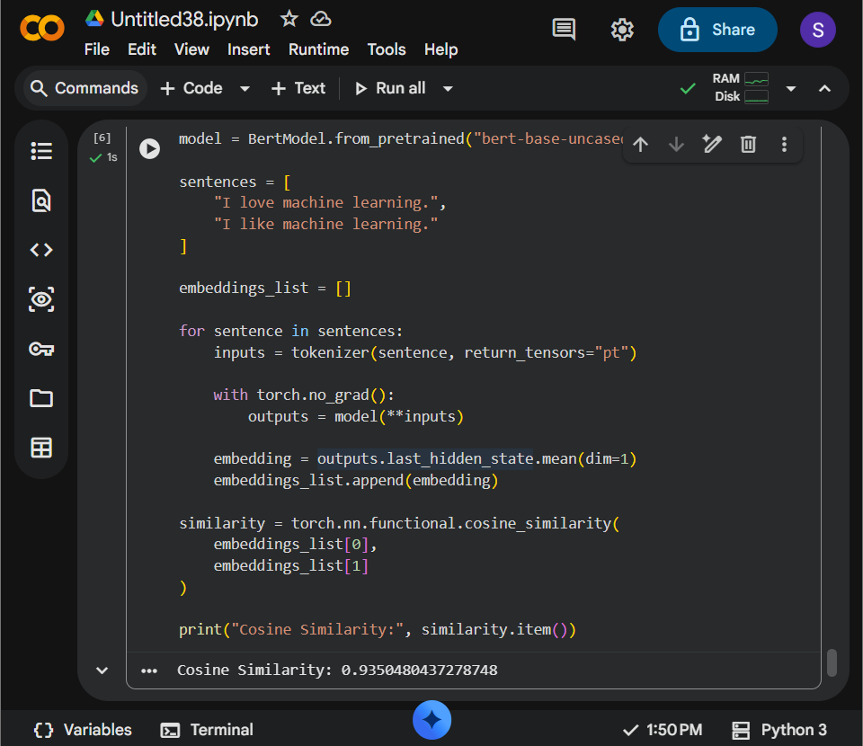
RESULT: Prints two sentence-embedding vectors (shape 2 x 384) and their cosine similarity. Similar meanings generally yield a higher similarity, but the exact score depends on the model.

PROGRAM 19
AIM: Generate text from a prompt using the GPT-2 language model.
CODE:
from transformers import AutoTokenizer, AutoModelForCausalLM
name = "gpt2"
tokenizer = AutoTokenizer.from_pretrained(name)
model = AutoModelForCausalLM.from_pretrained(name)
prompt = "In a small village, a young inventor discovered"
inputs = tokenizer(prompt, return_tensors="pt")
outputs = model.generate(
**inputs,
max_new_tokens=45,
do_sample=False,
pad_token_id=tokenizer.eos_token_id
)
print(tokenizer.decode(outputs[0], skip_special_tokens=True))
OUTPUT:

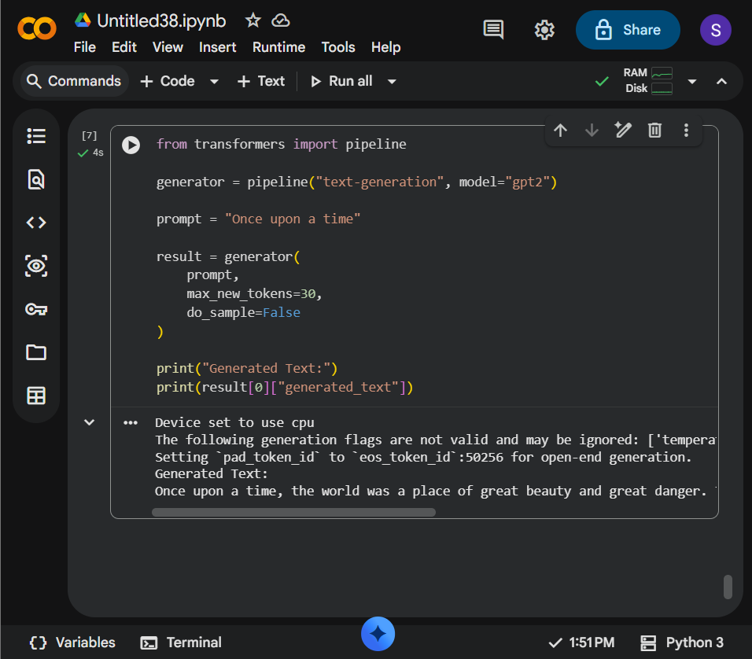
RESULT: Prints the prompt and a continuation generated by GPT-2. Greedy decoding is used, but exact output can still depend on model/library versions.

PROGRAM 20
AIM: Generate and compare responses for multiple prompts using a pre-trained LLM.
CODE:
from transformers import pipeline, set_seed
set_seed(42)
generator = pipeline("text-generation", model="gpt2")
prompts = [
"Explain machine learning in simple words:",
"Write one sentence about climate change:",
"Give a study tip for university students:"
]
for prompt in prompts:
result = generator(
prompt,
max_new_tokens=35,
do_sample=False,
pad_token_id=generator.tokenizer.eos_token_id
)
print("\nPrompt:", prompt)
print("Response:", result[0]["generated_text"][len(prompt):].strip())
OUTPUT:

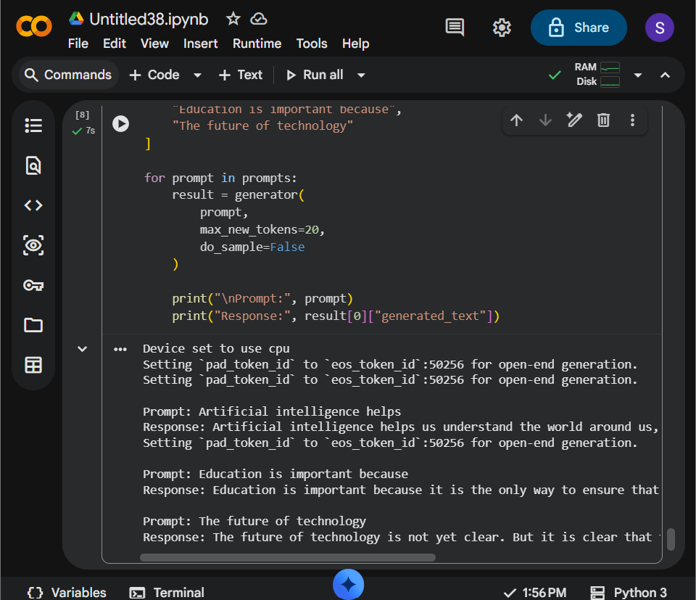
RESULT: Prints one generated continuation for each of the three prompts. GPT-2 is a language model rather than a guaranteed factual assistant; review outputs for accuracy.

